**SUPPLEMENTARY MATERIAL**

**Title: The nanostructure character of Arnica Montana** **as ultra high diluted succussed solution medicinal product. Recent advances and prospects.**

**Running head: Arnica Montana in nanoparticles form**

Dr D. Kalliantas a*, M. Kalliantab, Prof. K. Kordatos c, Prof. Ch. S. Karagianni a

aDepartment of Materials Science and Engineering, School of Chemical Engineering, NTUA, GR15780 Athens, Greece

b School of Dentistry, National and Kapodistrian University of Athens, Greece

c Department of Chemical Sciences, School of Chemical Engineering, NTUA, GR15780, Athens, Greece

*Corresponding author:

Dr D. Kalliantas, Department of Materials Science and Engineering, School of Chemical Engineering, NTUA, GR15780 Athens, Greece

Tel: +302107723280; Fax: +302107723184

Postal Address: National Technical University of Athens, 9 Heroon Polytechniou Str. Zografos Campus 15780

E-mail address: [dimitris@kalliadas.com](mailto:dimitris@kalliadas.com) (Dimitris Kalliantas.)

Table S1 DLS-Mastersizer micro results analysis table of Arnica M sample



Table S2 DLS-Mastersizer micro results analysis table of Arnica M 1X sample



Table S3 DLS-Mastersizer micro results analysis table of Arnica M 2X sample



Table S4 DLS-Mastersizer micro results analysis table of Arnica M 3X sample



Table S 5. Distributions of all potencies before and after succussion

|  |  |  |  |  |  |  |
| --- | --- | --- | --- | --- | --- | --- |
| Solutions | Distributions before succussion | | | Distributions after succussion | | |
| z-Average Size (dnm) | Pdi | Zeta Potential (mV) | z-Average Size (dnm) | Pdi | Zeta Potential (mV) |
| 4C | 1216 | 0.470 | -2,57 | 802.1 | 0.437 | -3,45 |
| 12C | 674,4 | 0,481 | -3,98 | 1750 | 0,910 | -291 |
| 30C | 1386 | 0,664 | -11,1 | 1673 | 0,863 | -9,07 |
| 200C | 1838 | 0,571 | -9,80 | 1616 | 0,790 | -10,9 |
| 1M | 1052 | 0,742 | -11,3 | 8933 | 0,198 | -10,8 |
| 10M | 1863 | 1,000 | -8,42 | 8730 | 0,511 | -9,21 |
| 50M | 477,4 | 0,337 | -19,2 | 8305 | 0,237 | -11,1 |

Table S 6. Electrical Conductivity - pH from initial up to 6X triturated samples of Arnica M.

|  |  |  |  |
| --- | --- | --- | --- |
| Potencies | Electrical Conductivity μS/cm | pH | Temperature0C |
| Initial | 804 | 5,03 | 18,7 |
| 1X | 135,9 | 4,05 | 18,8 |
| 2X or 1C | 30,7 | 3,80 | 19,3 |
| 3X | 26,8 | 3,62 | 20 |
| 4X or 2C | 24,7 | 3,53 | 19,8 |
| 5X | 27,5 | 3,71 | 19,8 |
| 6X 0r 3C | 52,6 | 3,56 | 18,3 |

C:\Users\Δημήτρης\Desktop\Arnica.tif

Figure S 1. FT-IR Spectrum of initial Arnica M sample

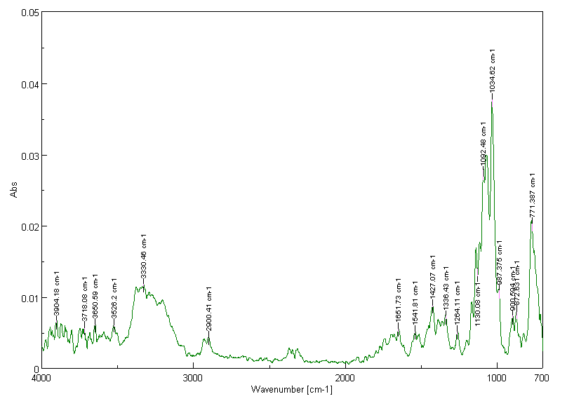

Figure S2. FT-IR Spectrum of first (1X) triturated Arnica M sample

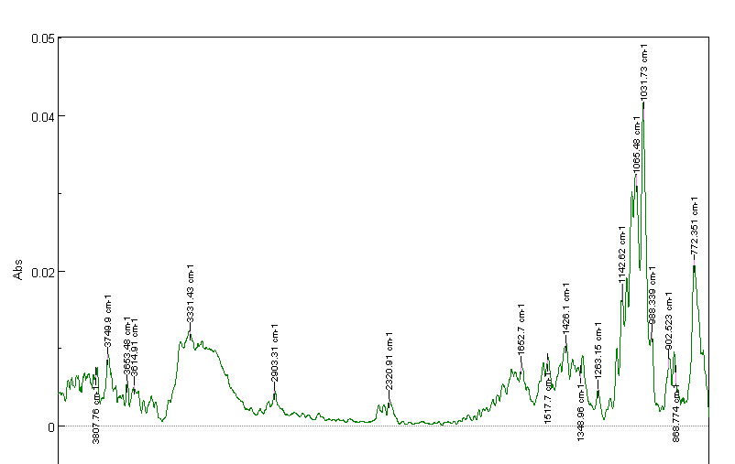

Figure S 3. FT-IR Spectrum of last (6X) triturated Arnica M sample

DLS-NANOSIZER results analysis graphs

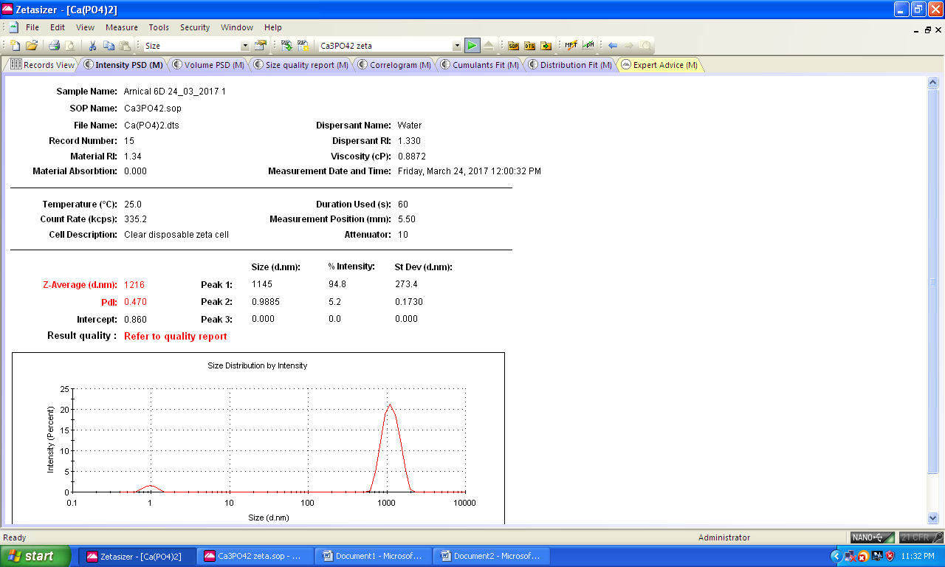

Figure S4 Size Distribution (dnm) by Intensity before Succussion of 4C Arnica M sample

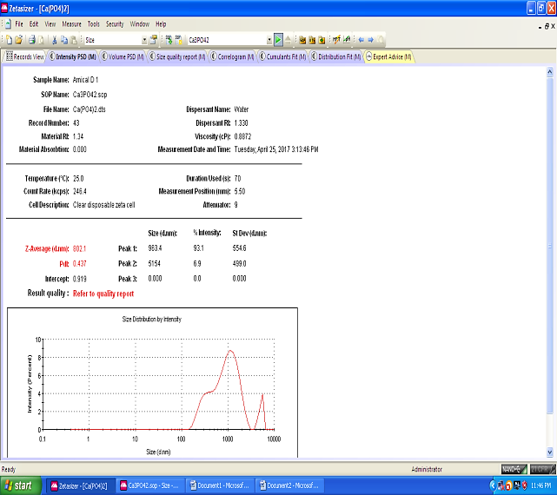

Figure S5 Size Distribution (dnm) by Intensity after Succussion of 4C Arnica M sample

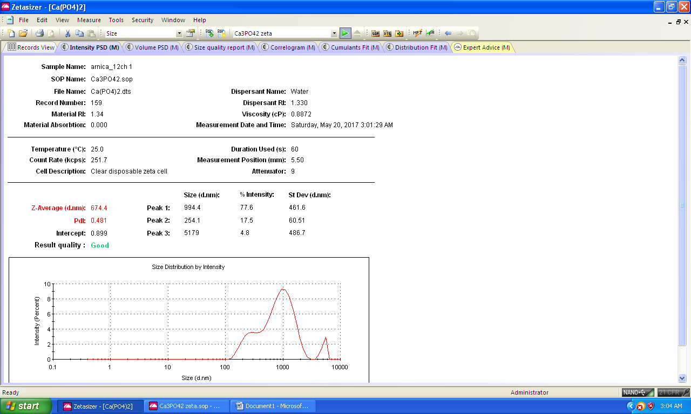

Figure S6 Size Distribution (dnm) by Intensity before Succussion of 12C Arnica M sample

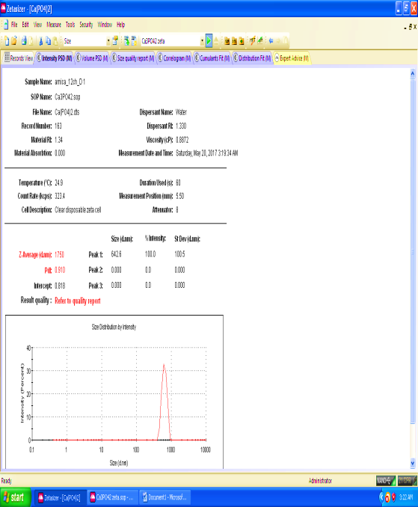

Figure S7 Size Distribution (dnm) by Intensity after Succussion of 12C Arnica M sample

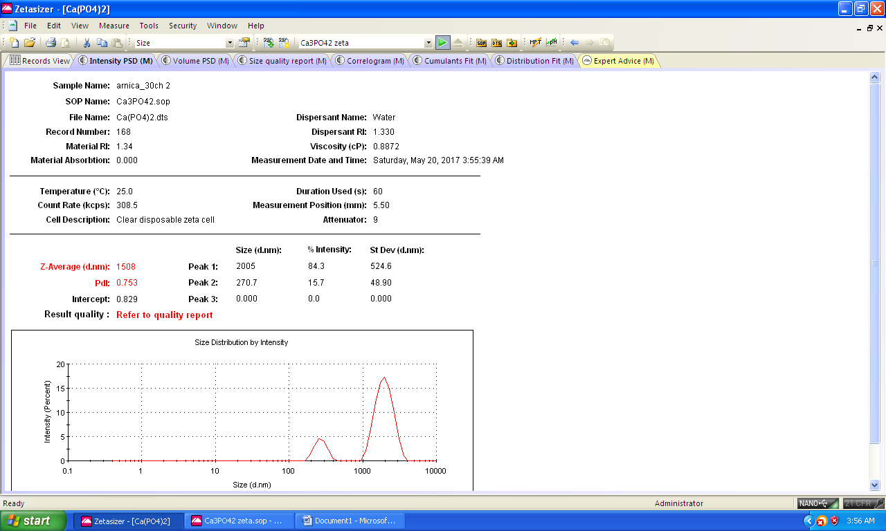

Figure S8 Size Distribution (dnm) by Intensity before Succussion of 30C Arnica M sample

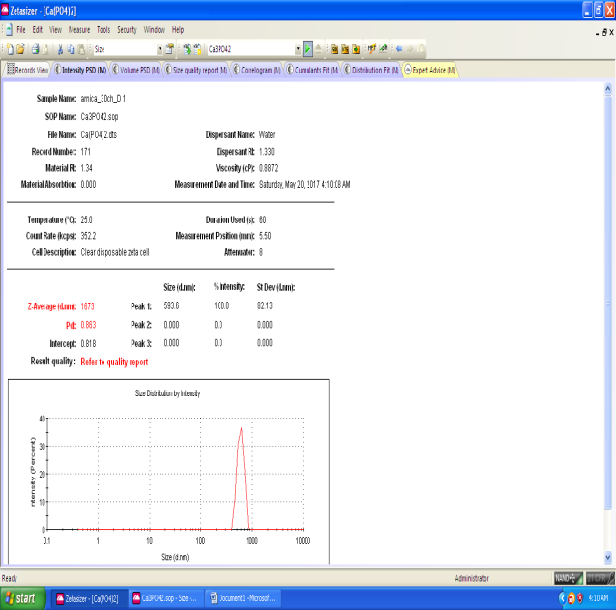

Figure S9 Size Distribution (dnm) by Intensity after Succussion of 30C Arnica M sample

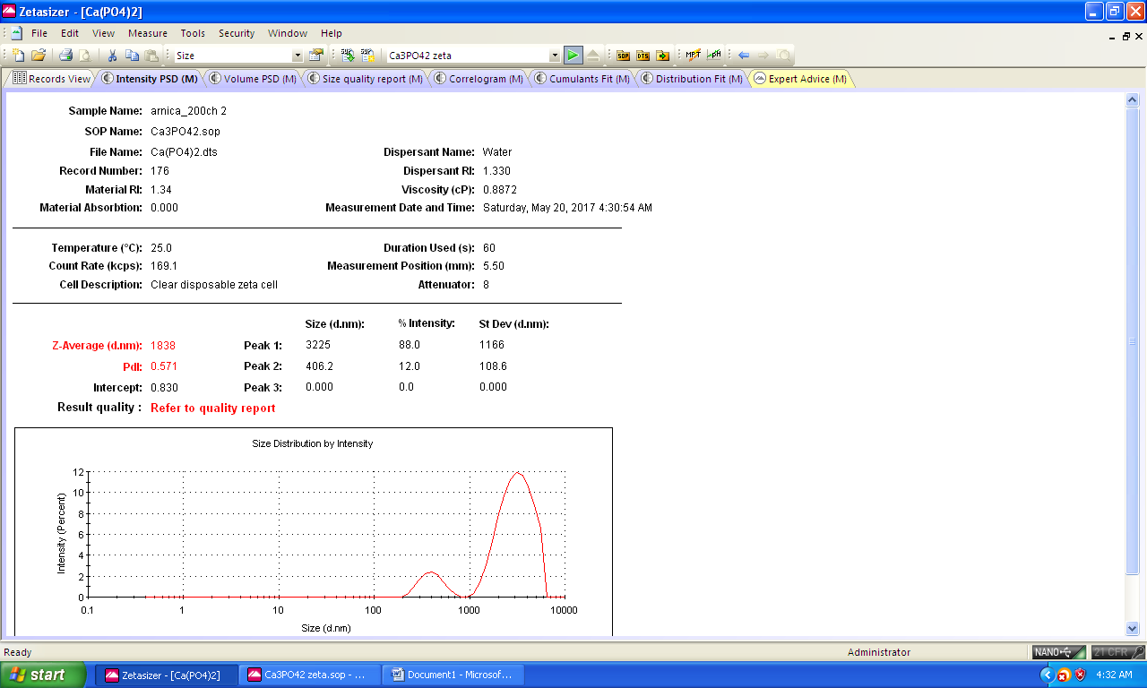

Figure S10 Size Distribution (dnm) by Intensity before Succussion of 200C Arnica M sample

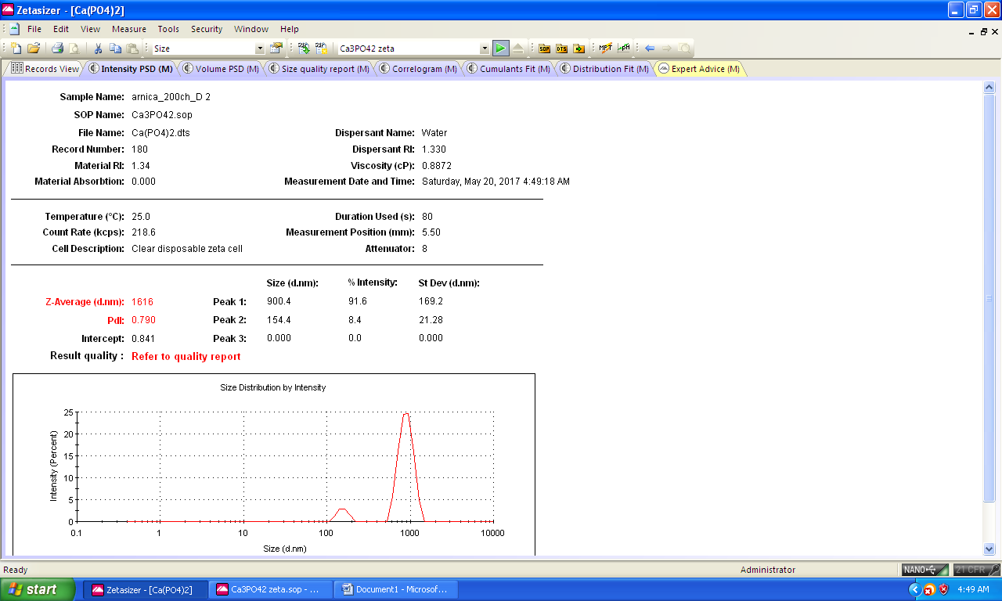

Figure S11 Size Distribution (dnm) by Intensity after Succussion of 200C Arnica M sample

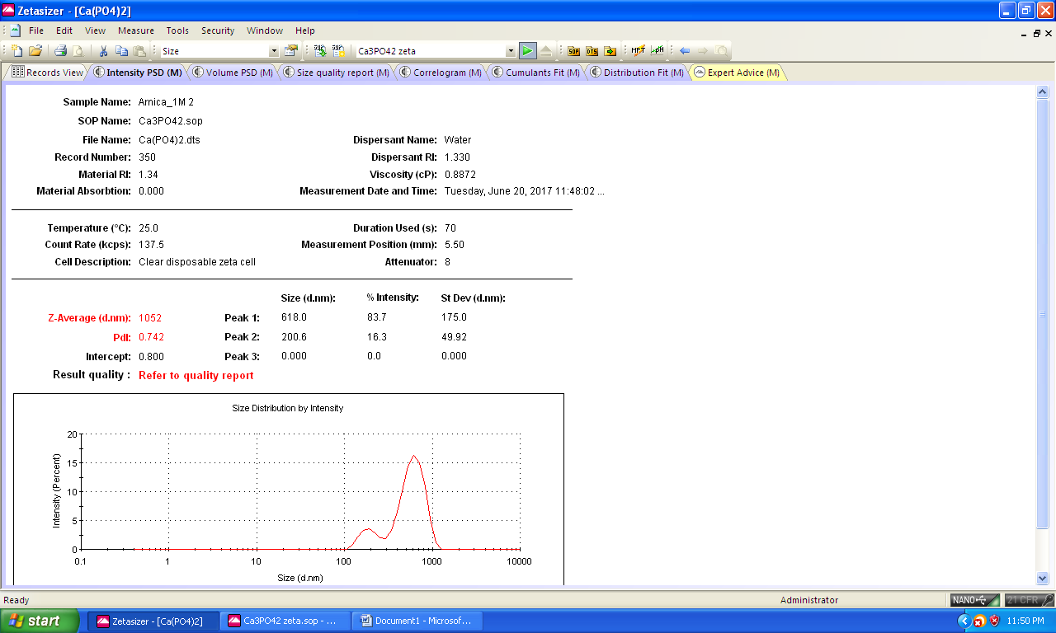

Figure S12 Size Distribution (dnm) by Intensity before Succussion of 1M Arnica M sample

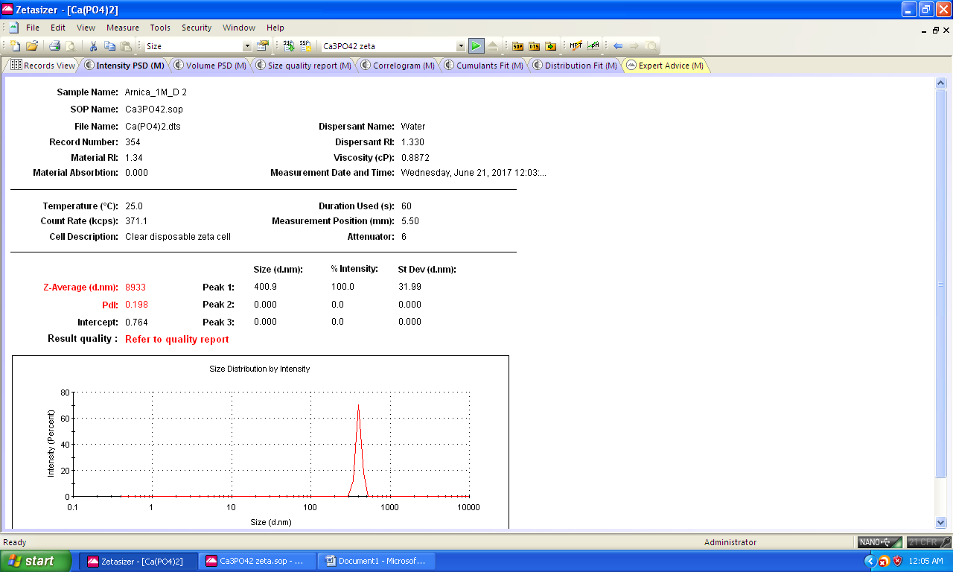

Figure S13 Size Distribution (dnm) by Intensity after Succussion of 1M Arnica M sample

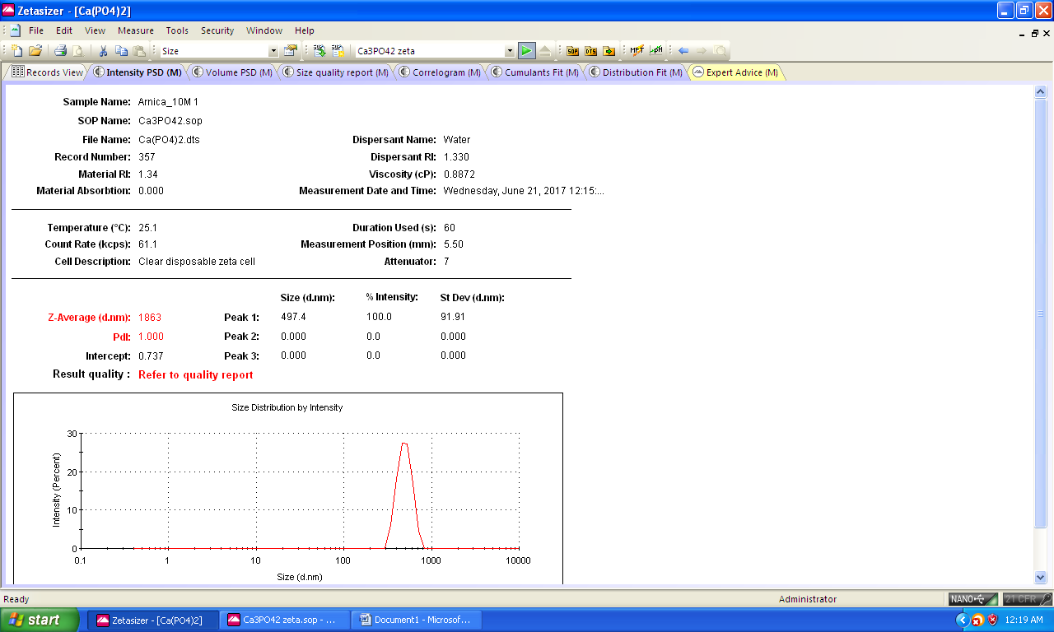

Figure S14 Size Distribution (dnm) by Intensity before Succussion of 10M Arnica M sample

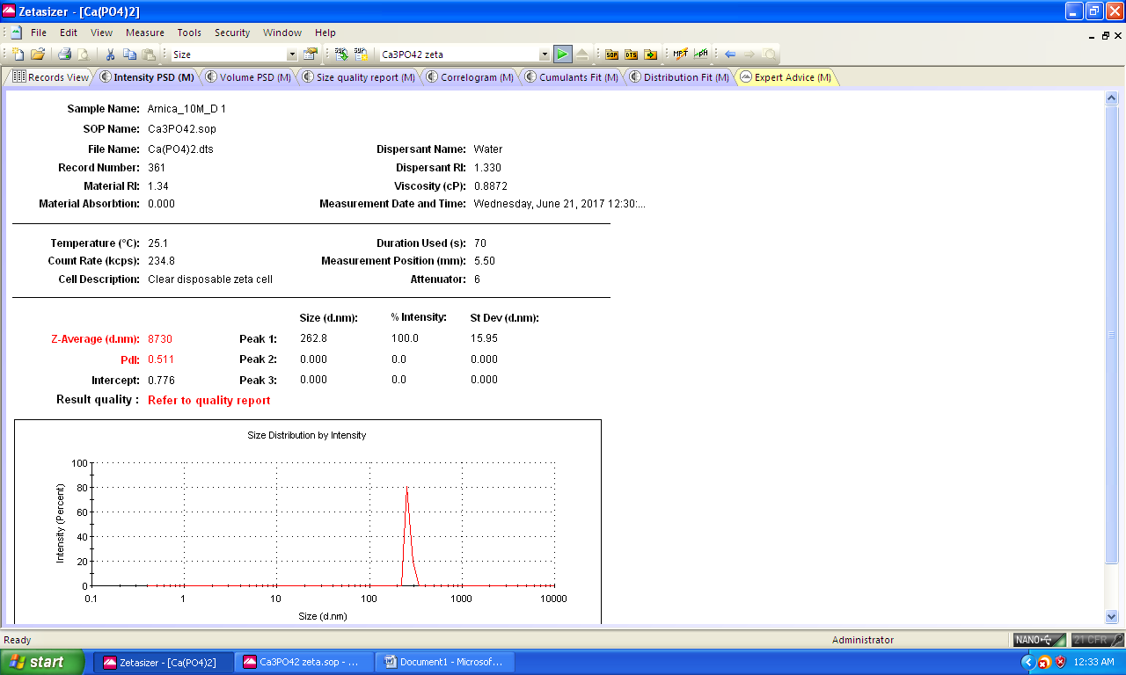

Figure S15 Size Distribution (dnm) by Intensity after Succussion of 10M Arnica M sample

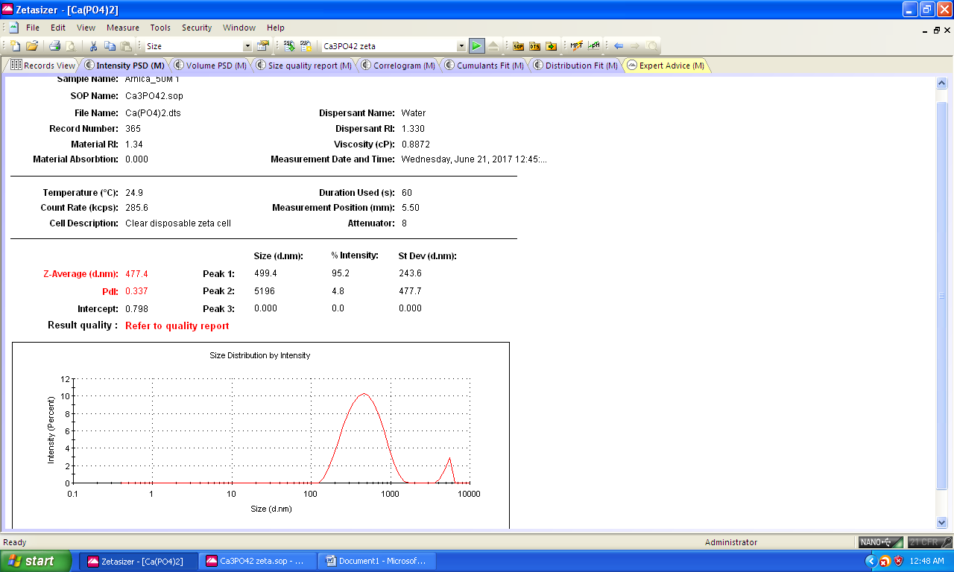

Figure S16 Size Distribution (dnm) by Intensity before Succussion of 50M Arnica M sample

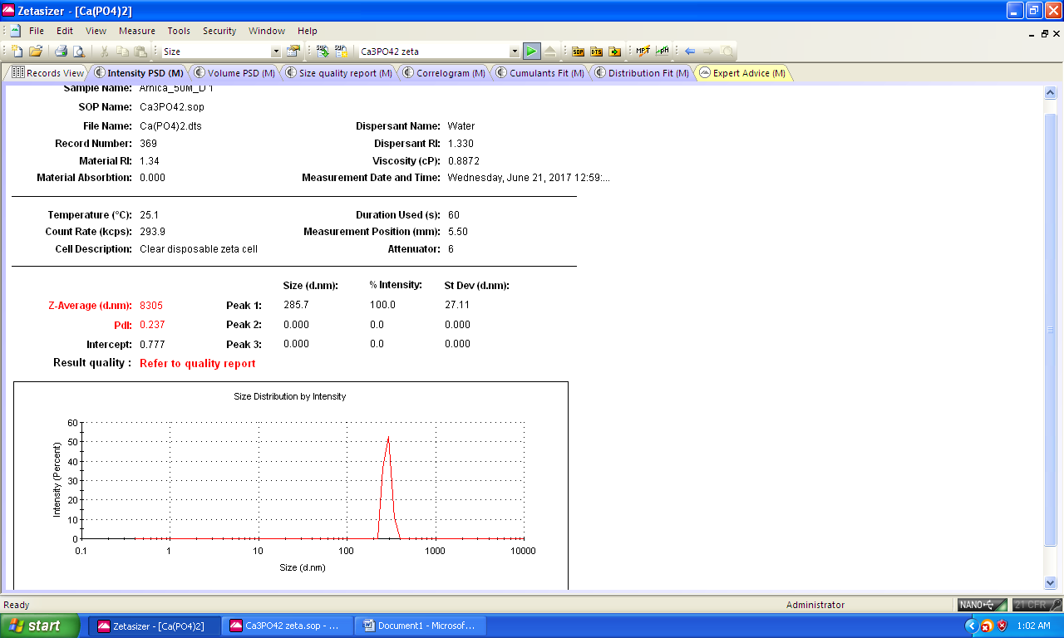

Figure S17 Size Distribution (dnm) by Intensity after Succussion of 50M Arnica M sample

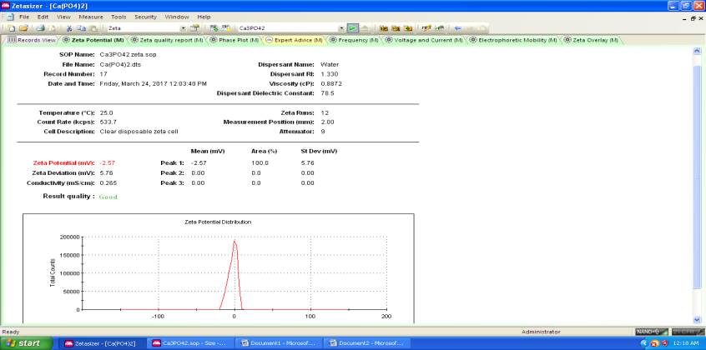

Figure S18 Zeta Potential (mV) before Succussion of 4C Arnica M sample

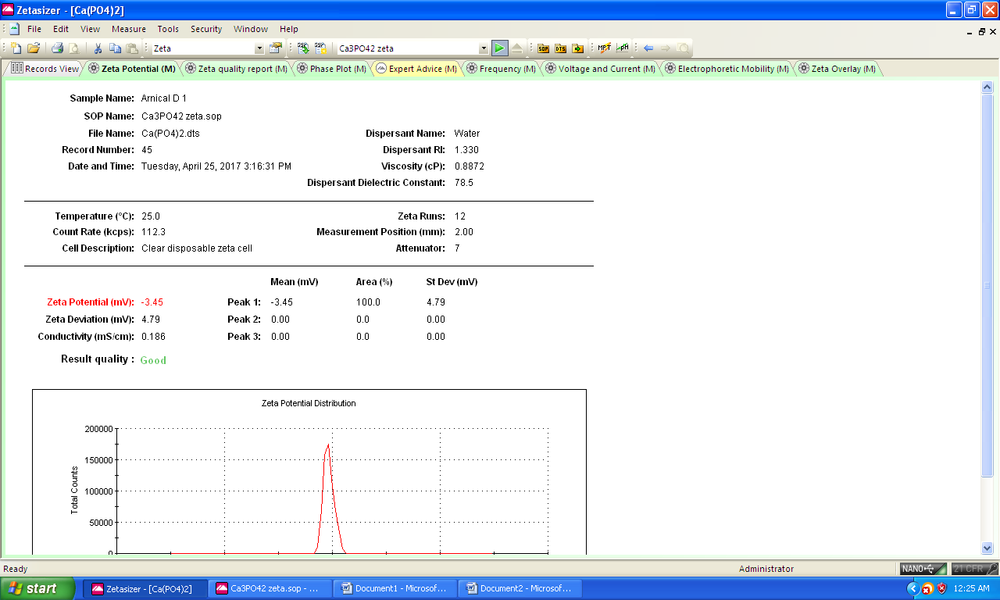

Figure S 19 Zeta Potential (mV) after Succussion of 4C Arnica M sample

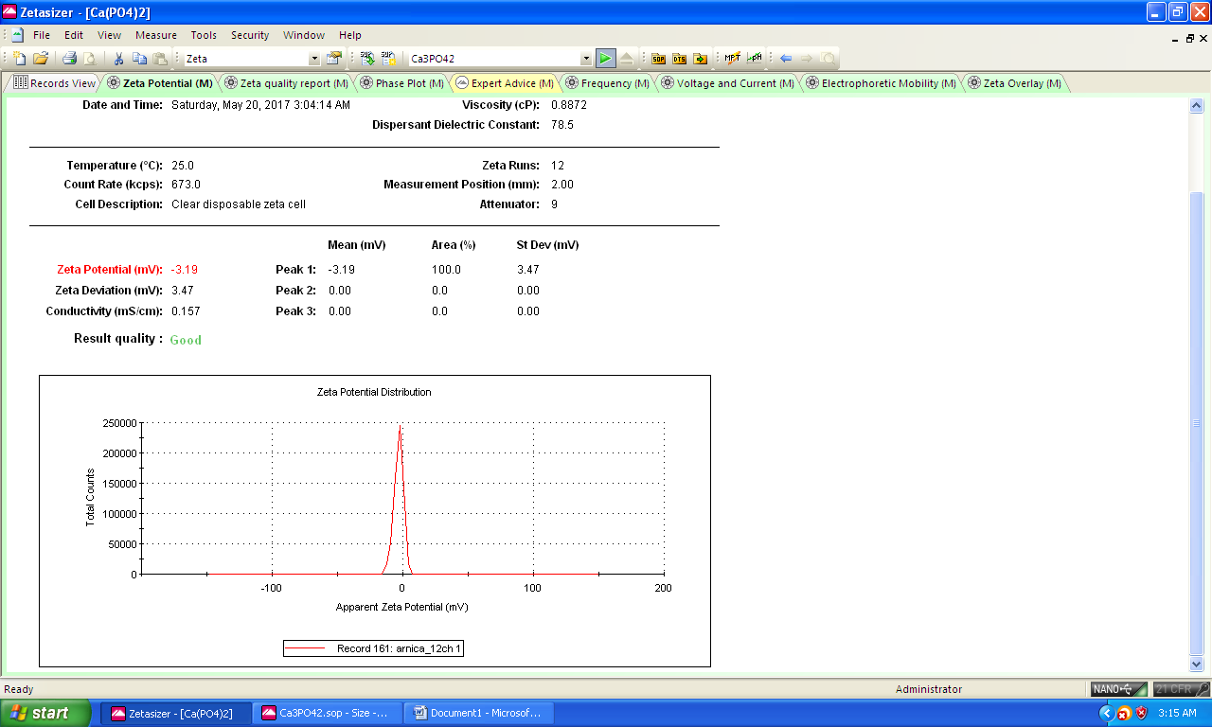

Figure S 20 Zeta Potential (mV) before Succussion of 12C Arnica M sample

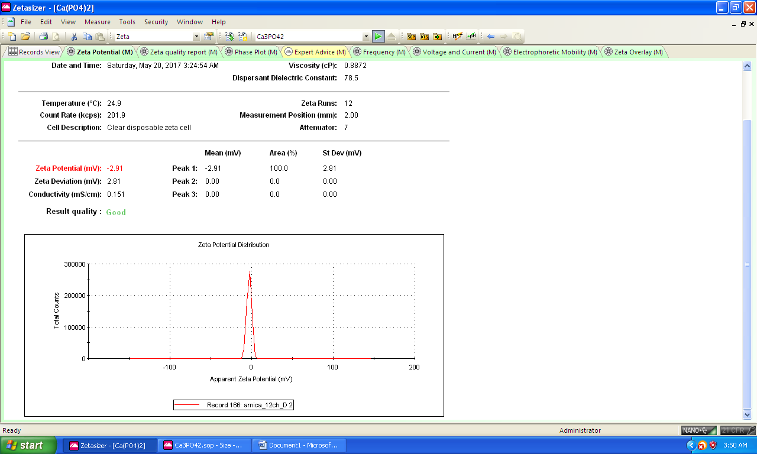

Figure S 21 Zeta Potential (mV) after Succussion of 12C Arnica M sample

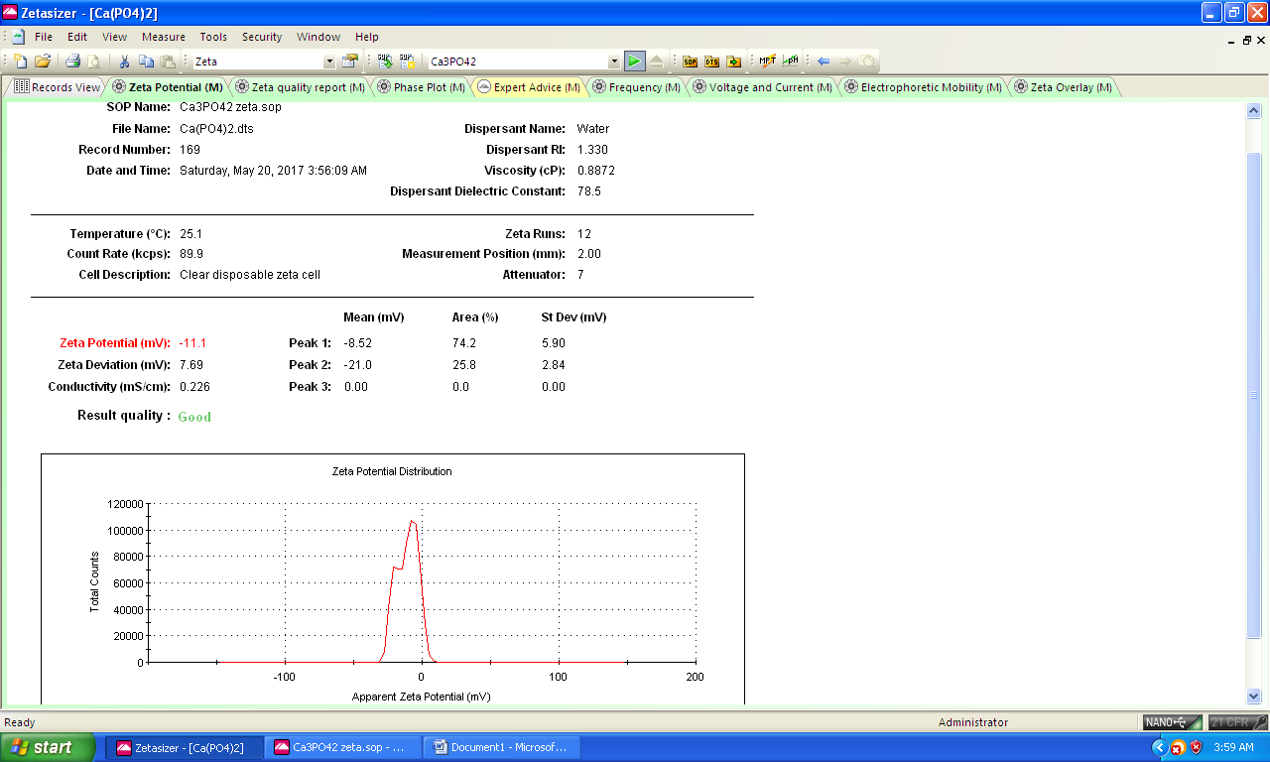

Figure S 22 Zeta Potential (mV) before Succussion of 30C Arnica M sample

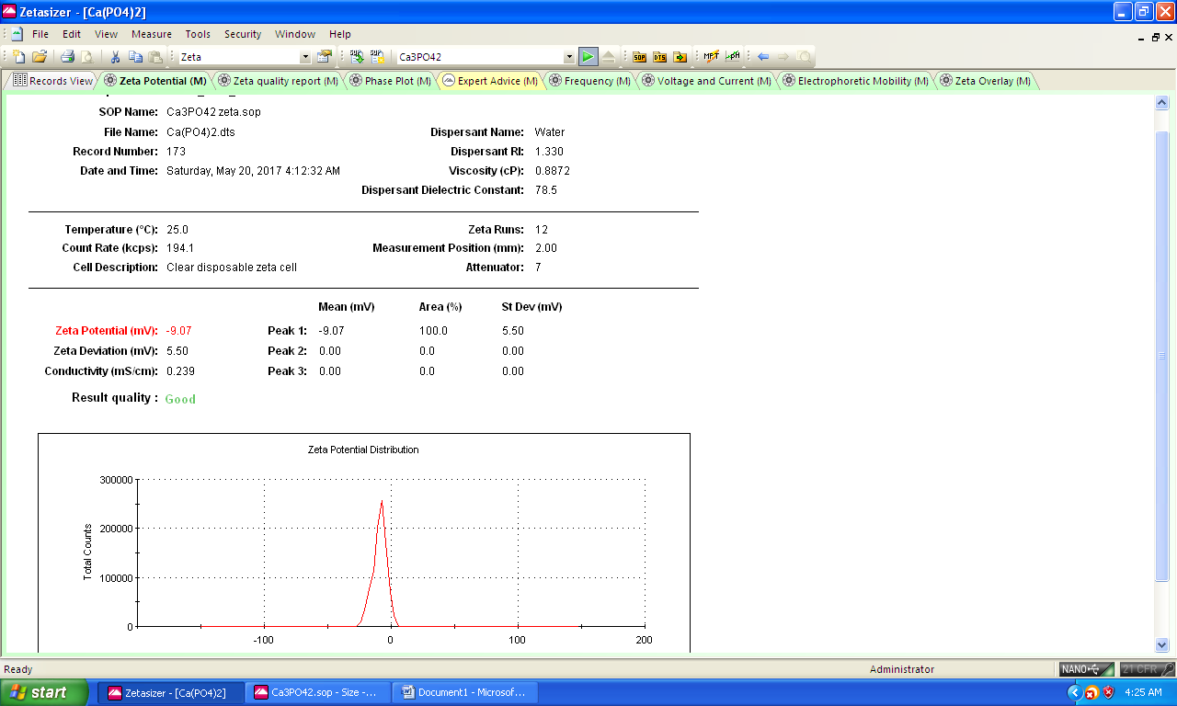

Figure S 23 Zeta Potential (mV) after Succussion of 30C Arnica M sample

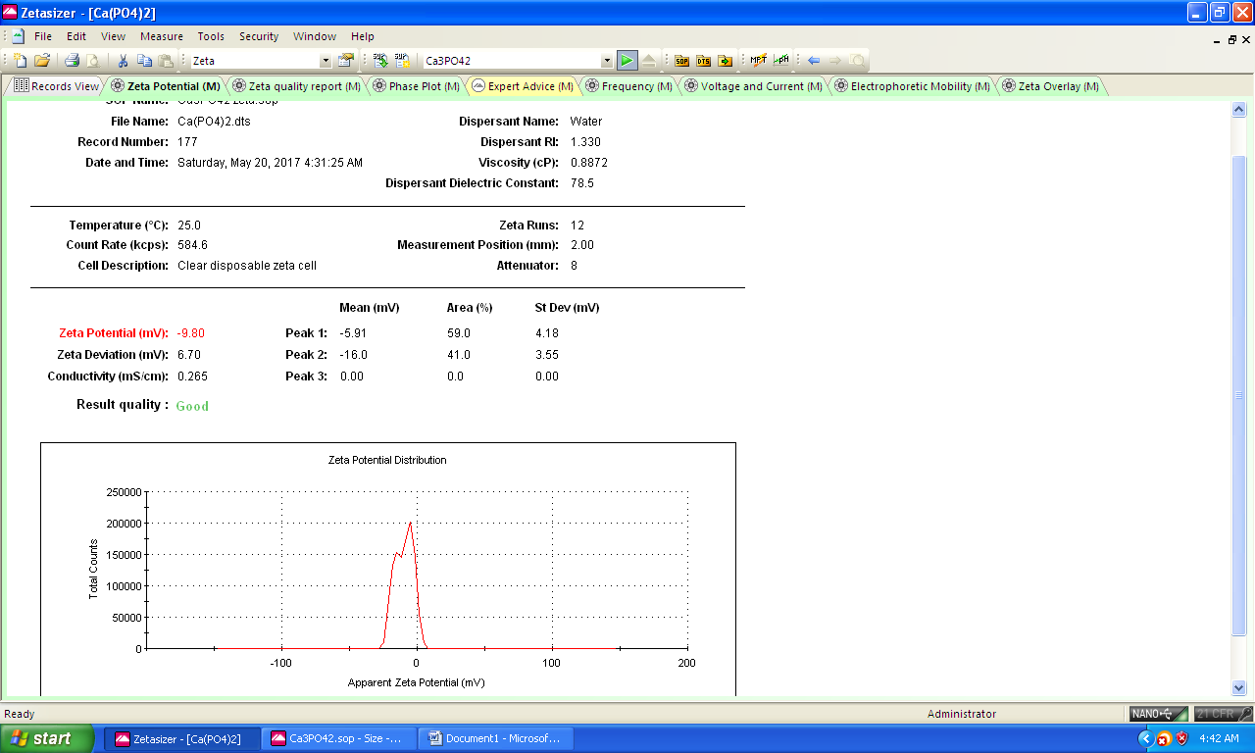

Figure S 24 Zeta Potential (mV) before Succussion of 200C Arnica M sample

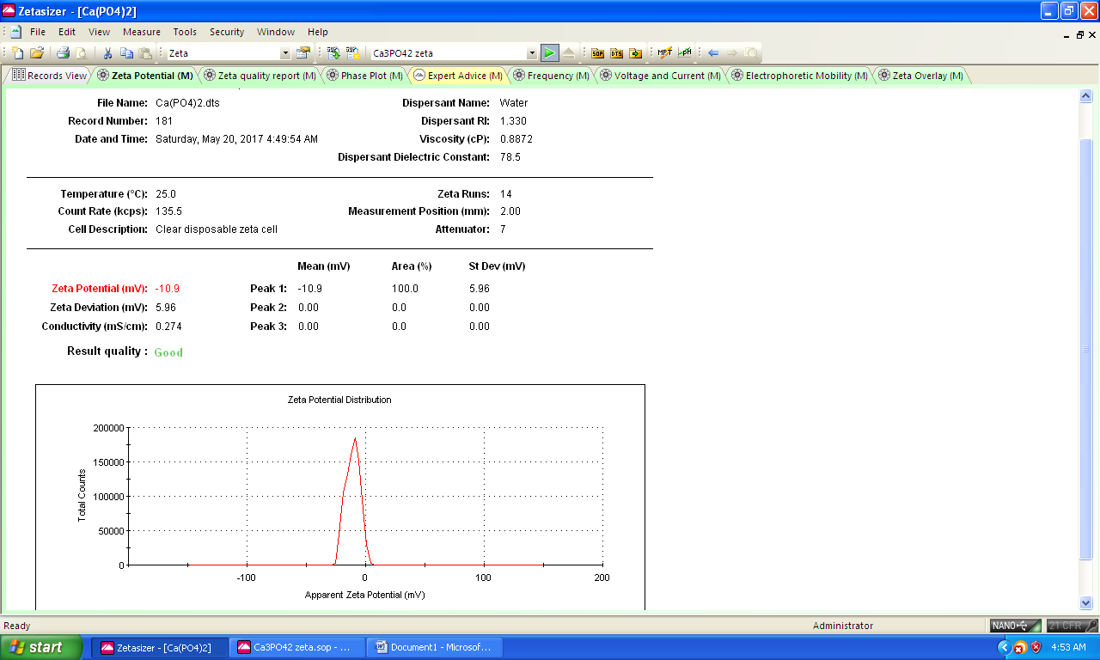

Figure S 25 Zeta Potential (mV) after Succussion of 200C Arnica M sample

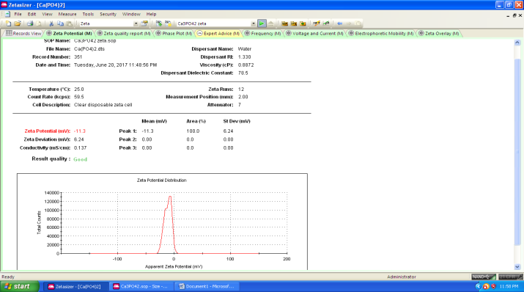

Figure S 26 Zeta Potential (mV) before Succussion of 1M Arnica M sample

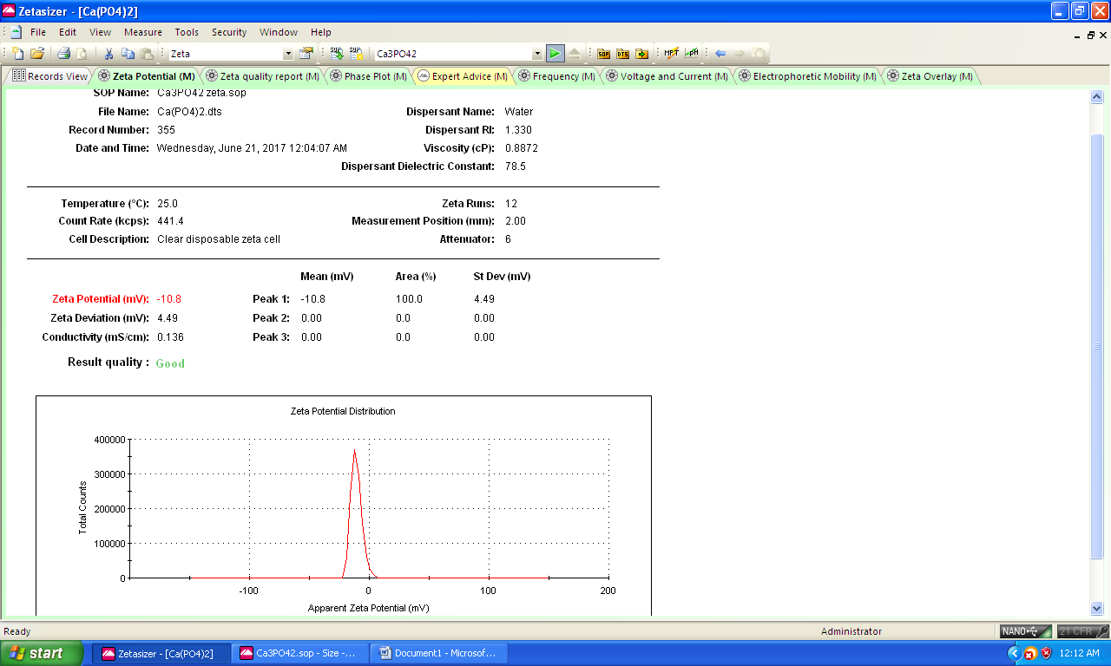

Figure S 27 Zeta Potential (mV) after Succussion of 1M Arnica M sample

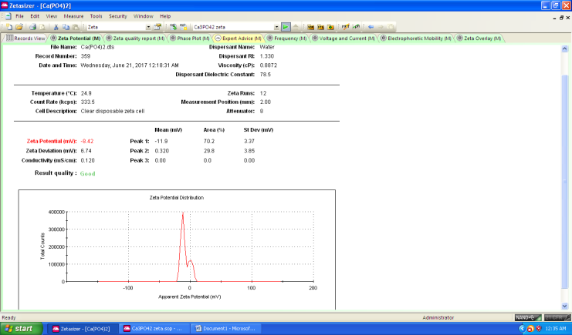

Figure S 28 Zeta Potential (mV) before Succussion of 10M Arnica M sample

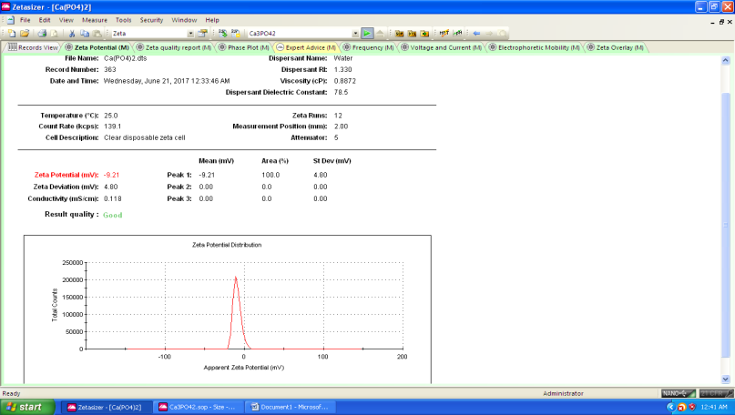

Figure S 29 Zeta Potential (mV) after Succussion of 10M Arnica M sample

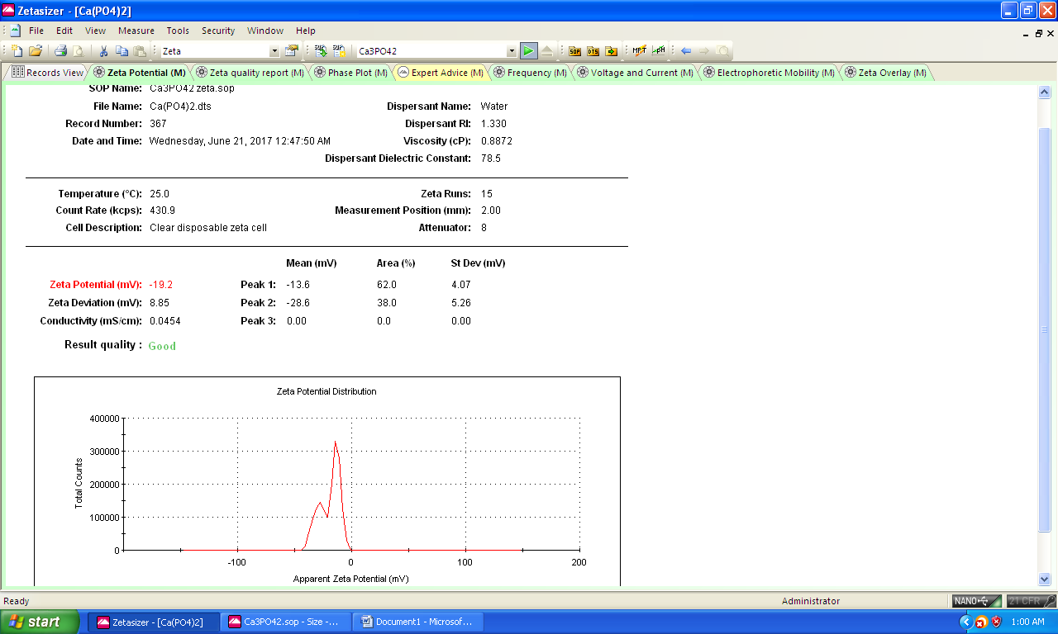

Figure S 30 Zeta Potential (mV) before Succussion of 50M Arnica M sample

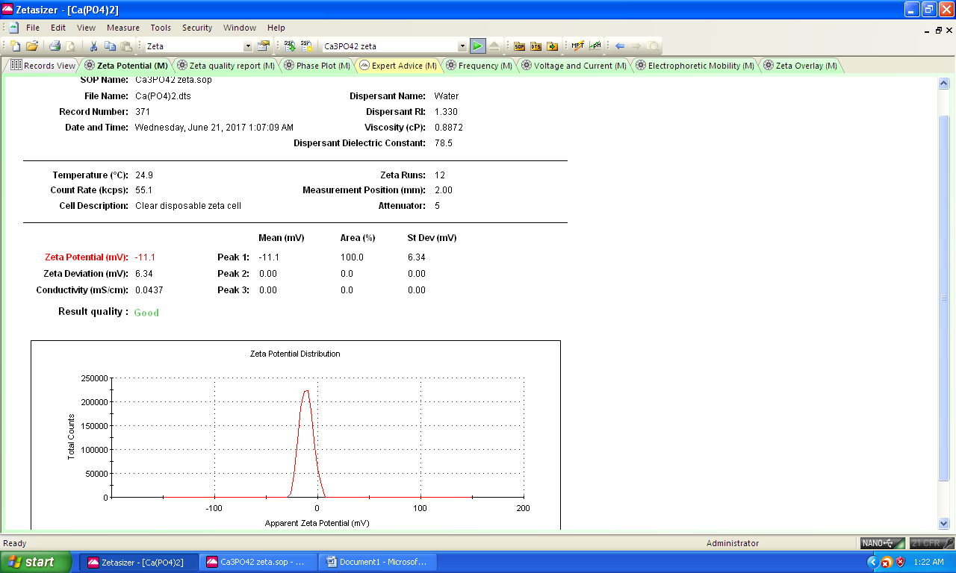

Figure S 31 Zeta Potential (mV) after Succussion of 50M Arnica M sample