Supplementary Figures

Supplementary Figure 1: GO enrichment analysis results for differential genes.

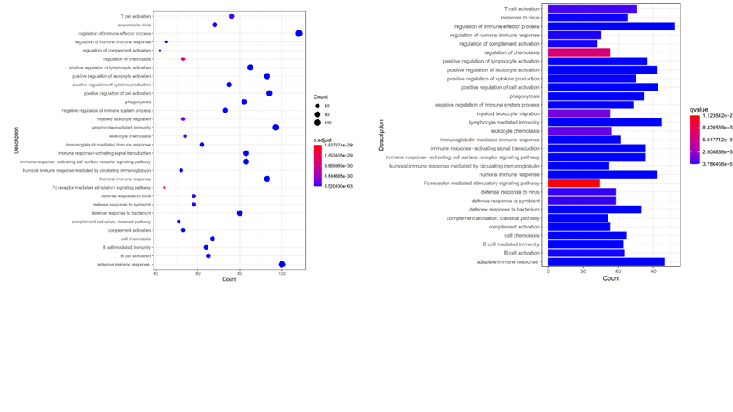
Supplementary Figure 2: Forest plot showed the result of multivariate cox analysis
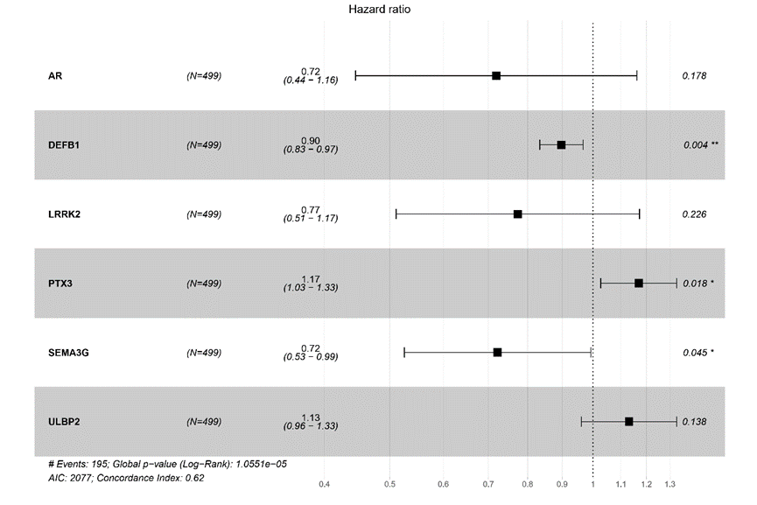

Supplementary Figure 3: Kaplan Meier analysis revealed that up-expression of AR, DEFB1, LRRK2, SEMA3G and down-expression of ULBP2, PTX3 were associated with better survival outcomes and low recurrence.

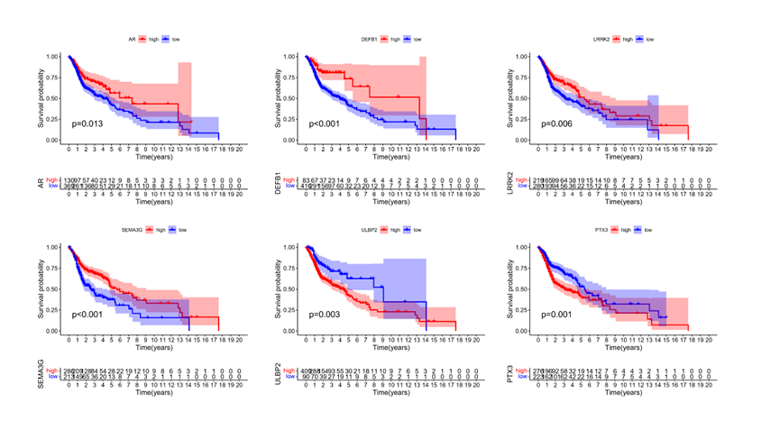
Supplementary Figure 4: Kaplan Meier analysis revealed that GEO verification database. (A) GSE65858. (B) GSE85446.

Supplementary Figure 5: Kaplan Meier analysis revealed that up-expression of B cell native, Mast cells resting, Plasma cells, T cells follicular helper, T cells regulatory (Tregs) and down-expression of Dendritic cells resting, Macrophages M2, Neutrophils, Mast cells activated were associated with better survival outcomes and low recurrence

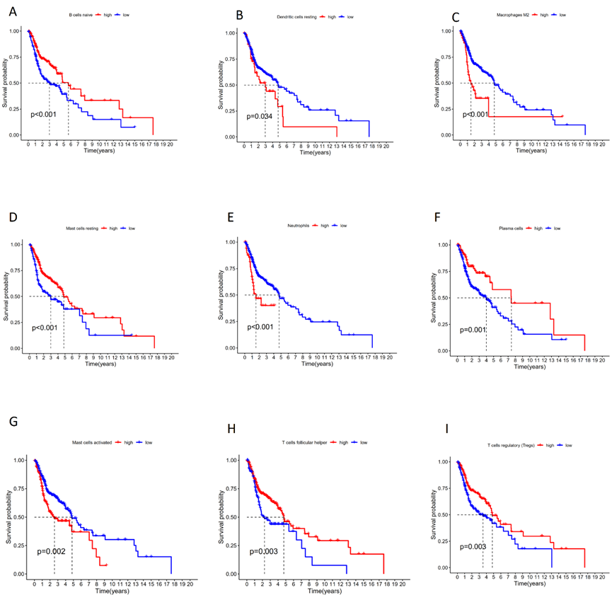

Supplementary Figure 6: (A-D) High risk score was correlated with less immune cell infiltration and lower immune signature enrichment. Kaplan Meier analysis revealed grouping prognosis. ( P<0.001)

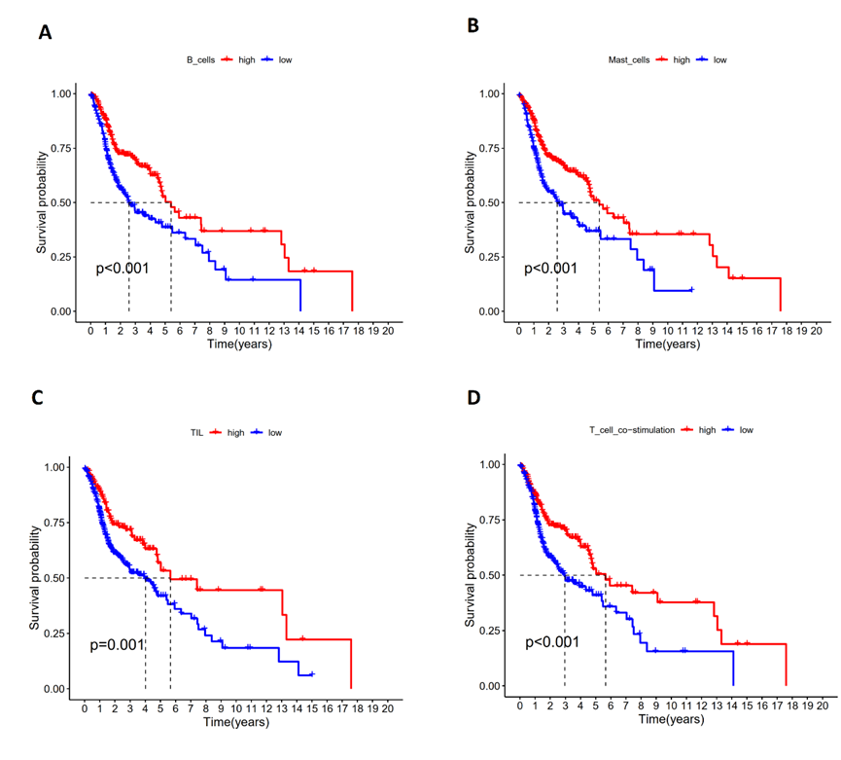
Supplementary Figure 7: Validation of Three IRGPIs mRNA Expression in Tissues (P<0.05)
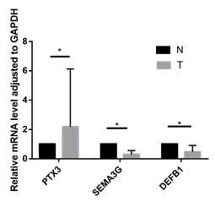

Baseline data of clinical information integrity 527 HNSC patients from TCGA cohort.

Variables | TCGA cohort(n=527)
Age
<65 | 330(62.6%)
≥65 | 197(37.4%)
Gender
Male | 385(73.1%)
Female | 142(26.9%)
Pathology grade
G1+ G2 | 373(70.8%)
G3+G4 | 132(25.0%)
Unknow | 22(4.2%)
Clinical stage
Stage I+II | 100(19%)
Stage III+IV | 352(66.8%)
unknow | 75(14.2%)
AJCC T
T0+T1+T2 | 189(35.9%)
T3+T4 | 276(64.1%)
unknow | 62(9.9%)
AJCC N
N0+N1 | 247(46.9%)
N2+N3 | 180(34.1%)
unknow | 100(19%)
AJCC M
M0 | 190(36.1%)
M1 | 1(0.1%)
unknow | 336(63.8%)

